Topics: Descriptive Statistics and Probability

- Look at the data given below. Plot the data, find the outliers and find out $μ, σ, σ^{2}$

Name of company | Measure X
Allied Signal | 24.23%
Bankers Trust | 25.53%
General Mills | 25.41%
ITT Industries | 24.14%
J.P.Morgan& Co. | 29.62%
Lehman Brothers | 28.25%
Marriott | 25.81%
MCI | 24.39%
Merrill Lynch | 40.26%
Microsoft | 32.95%
Morgan Stanley | 91.36%
Sun Microsystems | 25.99%
Travelers | 39.42%
US Airways | 26.71%
Warner-Lambert | 35.00%
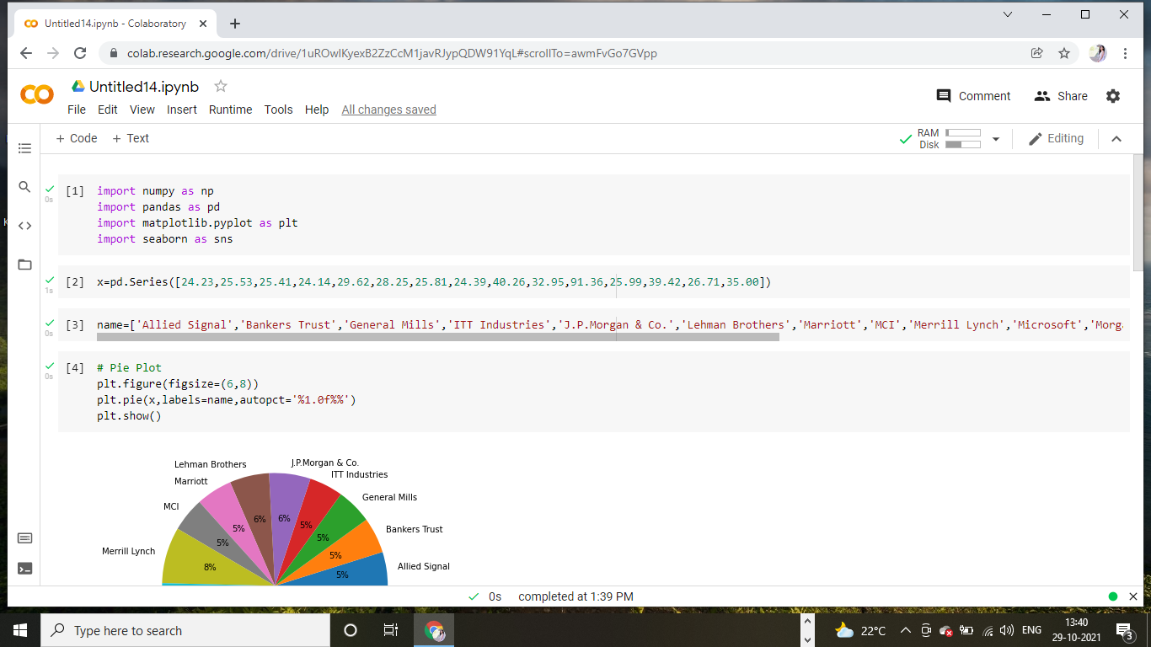

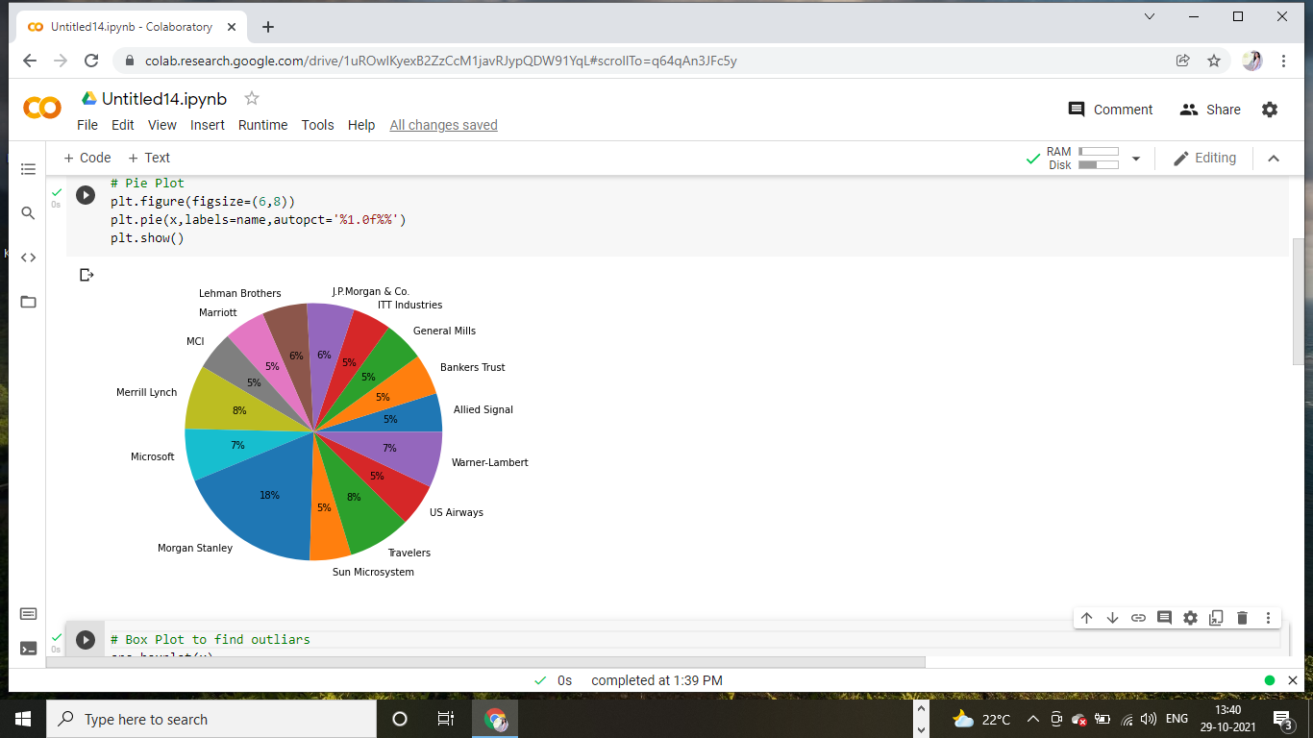
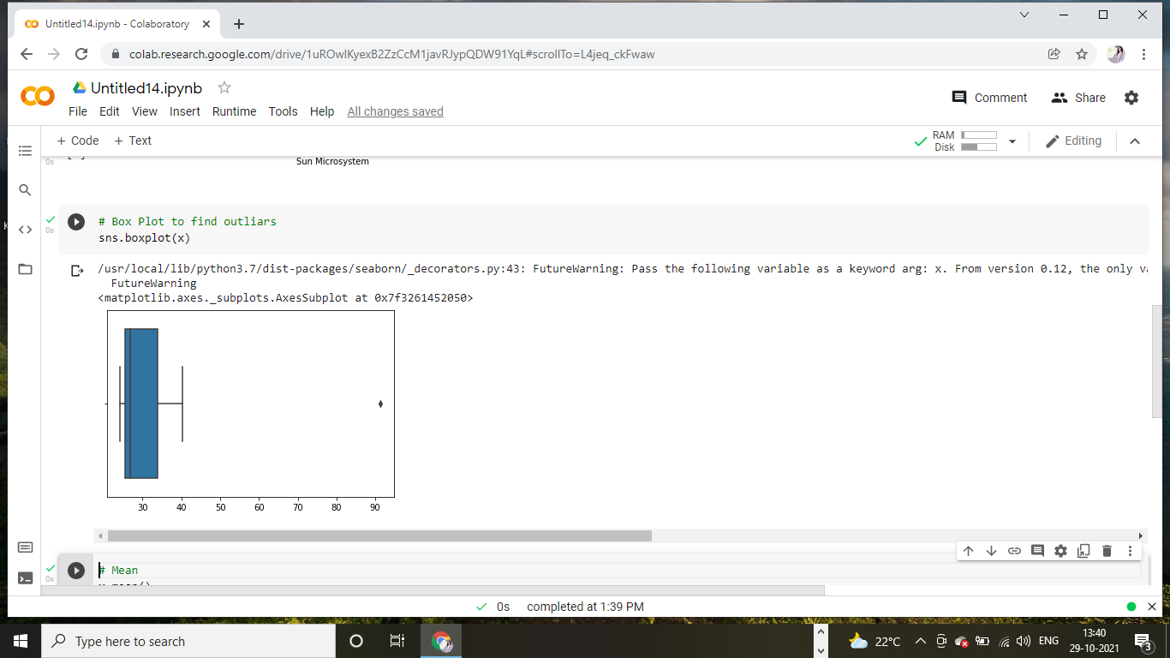
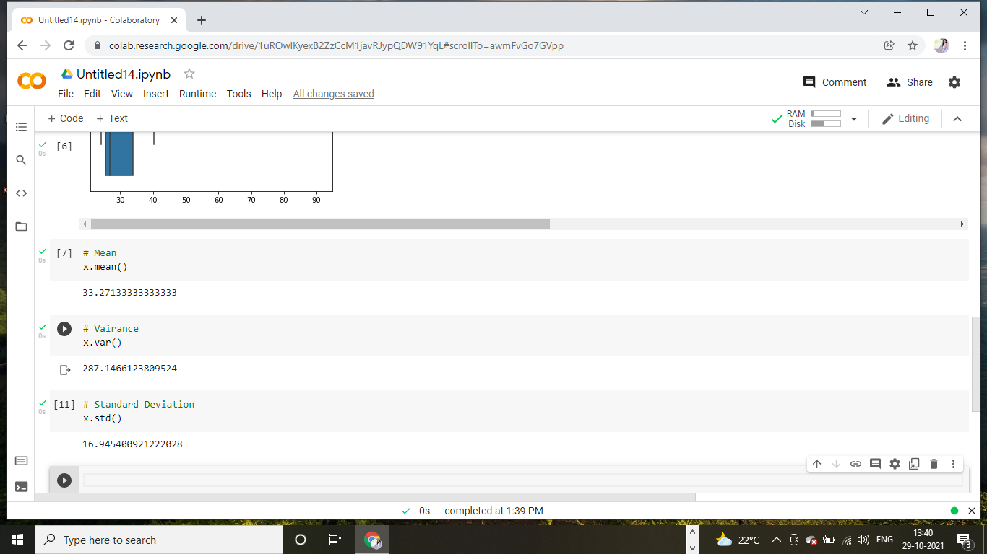

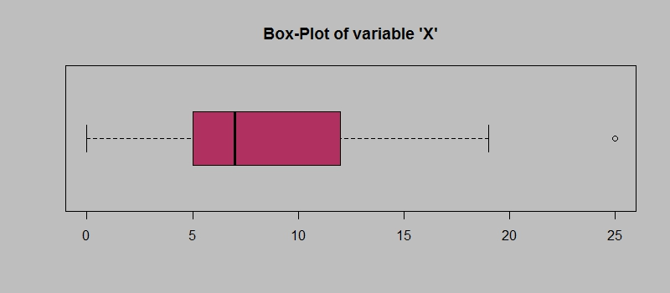
Answer the following three questions based on the box-plot above.
- What is inter-quartile range of this dataset? (please approximate the numbers) In one line, explain what this value implies.
Answer:
Range from 5 to 12. Viscous 0 to 19. And 1 outlier.
- What can we say about the skewness of this dataset?
Answer:
Left skewness.
- If it was found that the data point with the value 25 is actually 2.5, how would the new box-plot be affected?
Answer:
It scale the chart 3.

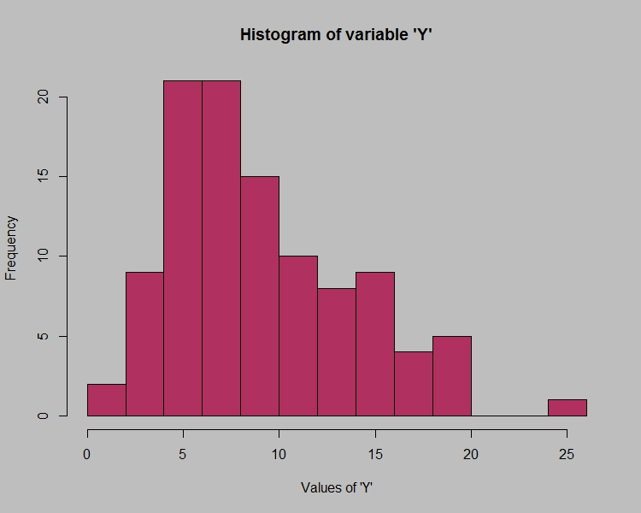
Figure 1
Answer the following three questions based on the histogram above.
- Where would the mode of this dataset lie?
Answer:
4 to 8.
- Comment on the skewness of the dataset.
Answer:
Left skewness.
- Suppose that the above histogram and the box-plot in question 2 are plotted for the same dataset. Explain how these graphs complement each other in providing information about any dataset.
Answer:
We cant diff mode in box plot but we can do that in hist.

- AT&T was running commercials in 1990 aimed at luring back customers who had switched to one of the other long-distance phone service providers. One such commercial shows a businessman trying to reach Phoenix and mistakenly getting Fiji, where a half-naked native on a beach responds incomprehensibly in Polynesian. When asked about this advertisement, AT&T admitted that the portrayed incident did not actually take place but added that this was an enactment of something that “could happen.” Suppose that one in 200 long-distance telephone calls is misdirected. What is the probability that at least one in five attempted telephone calls reaches the wrong number? (Assume independence of attempts.)

Answer:
Given: one in 200 long-distance telephone calls is misdirected.
To find: probability that at least one in five attempted telephone calls reaches the wrong number
Solution: one in 200 long distance telephone calls is misdirected
=>probability of call misdirected p=1/200
Probability of call not misdirected=1-1/200=199/200
Number of calls =5
P(x)=nCx.ppowerx.qpowern-x
n=5
p=1/200
q=199/200
at least one in five attempted telephone calls reaches the wrong number
=1-none of the call reaches the wrong number
=1-P(0)
=1-5C0(1/200)power0.(199/200)power5-0
=1-(199/200)power5
=0.02475
Probability that at least one in five attempted telephone calls reaches the wrong number=0.02475.

- Returns on a certain business venture, to the nearest $1,000, are known to follow the following probability distribution
x | P(x)
-2,000 | 0.1
-1,000 | 0.1
0 | 0.2
1000 | 0.2
2000 | 0.3
3000 | 0.1

- What is the most likely monetary outcome of the business venture?
- Is the venture likely to be successful? Explain
- What is the long-term average earning of business ventures of this kind? Explain
- What is the good measure of the risk involved in a venture of this kind? Compute this measure
Answer:
To find: most likely monetary outcome of the business venture
Is the venture likely to be successful.
What is the long-term average earning of business ventures if this kind.
Solution:
Most likely monetary outcome of the business venture is 2000 $
As it has maximum probability=0.3
E(X) P(x) E(X)P(X)
-2,000 0.1 -200
-1,000 0.1 -100
0 0.2 200
2000 0.3 600
3000 0.1 300
800
Expected value=summationE(X)P(X)=800
Long-term average earning of business venture=800$
Venture is likely to be successful as
Expected value is+ve=800$

